Confederation Park
Primary (K-3) Supply List
September 2021

For the 2021-2022 school year, the Primary teachers will be organizing and purchasing school supplies rather than each child bringing individual supplies.
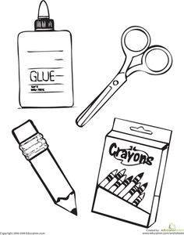
We will collect $30 per student (payable via School Cash Online in September, see reverse for details) for school supplies such as pencils, sharpies, scissors, washable markers, duo-tangs, glue etc.

Families will still be expected to provide the following items:

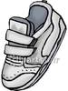
- 1 pair of running shoes, preferably velcro and white soled (to be left at school and used inside only)
- 1 backpack (large enough to accommodate books, notices, etc.)
- A complete change of clothes in a drawstring bag (wet days & accidents)
- Weather Appropriate clothing (Rain boots, rain suit or pants, coat with a hood)

Please label all of the above items with your child’s name.

