CONFEDERATION PARK SCHOOL’s

BOOMERANG CLUB

RETURN THIS CONSENT FORM IF YOU ARE INTERESTED IN JOINING THE BOOMERANG CLUB.

STUDENT NAME_______________________________ DIV._______

PARENT SIGNTURE _________________________________________

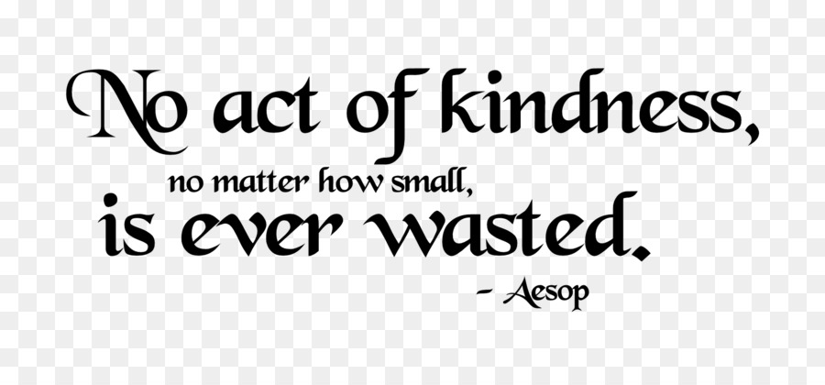

WHAT DO YOU DO?

Well, this depends on the students. The club is driven by student voice, ideas and initiatives. Perhaps some ideas may be presenting at assemblies, organizing school activities, reaching out to the community, and much more!

WHO IS IT FOR?

Interested students from grades 4 – 7.